Exercise: Object Composition
Problems for exercises and homework for the "JavaScript Advanced" course @ SoftUni. Submit your solutions in the SoftUni judge system at https://judge.softuni.bg/Contests/1546.

Array Extension
Extend the build-in Array object with additional functionality. Implement the following functionality:
- last() - returns the last element of the array
- skip(n) - returns a new array which includes all original elements, except the first n elements; n is a Number parameter
- take(n) - returns a new array containing the first n elements from the original array; n is a Number parameter
- sum() - returns a sum of all array elements
- average() - returns the average of all array elements

Input / Output
Input for functions that expect it will be passed as valid parameters. Output from functions should be their return value.

Constraints
Structure your code as an IIFE.

Hints
If we have an instance of and array, since we know it’s an object, adding new properties to it is pretty straightforward:
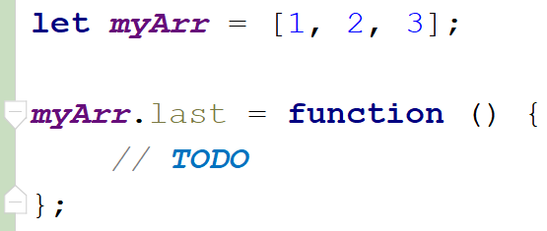
This however, only adds our new function to this instance. To add all functions just one time and have them work on all arrays is not much more complicated, we just have to attach them to Array’s prototype instead:
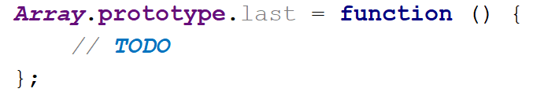
With such a declaration, we gain access to the context of the calling instance via this. We can then easily access indexes and other existing properties. Don’t forget we don’t want to modify the exiting array, but to create a new one:

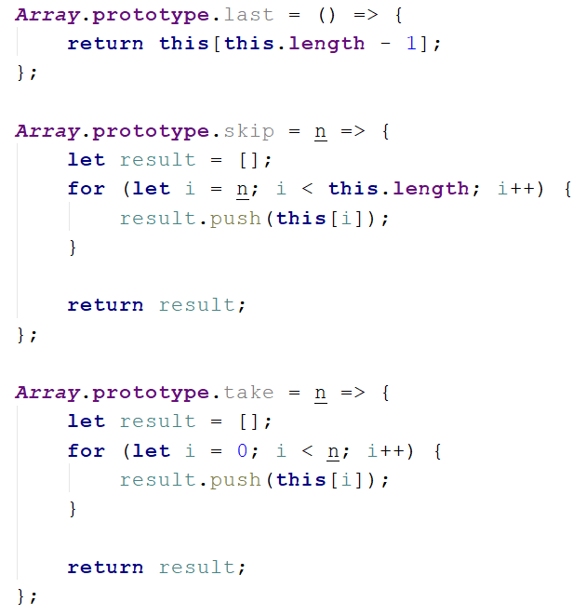
Note these functions do not have any error checking - if n is negative or outside the bounds of the array, and exception will be thrown, so take care when using them, or add your own validation. The last two functions require a little bit of arithmetic to be performed:
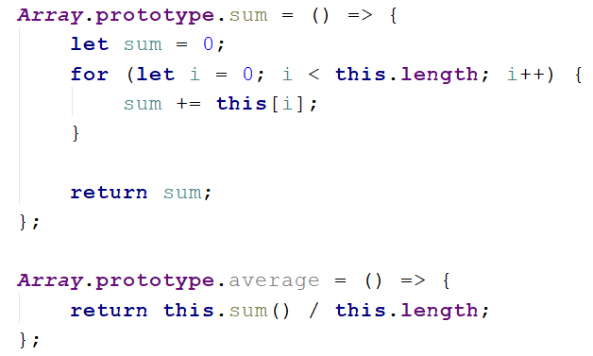
To test our program in the Judge, we need to wrap it in an IIFE, like it’s shown on the right. There is no return value, since the code execution results in functionality being added to and existing object, so they take effect instantly. We are ready to submit our solution.
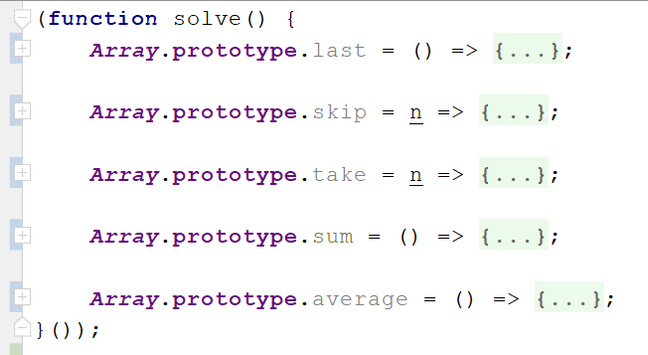

Construction Crew
Write a program that receives a worker object as a parameter and modifies its properties. Workers have the following structure:
{ weight: Number,
experience: Number,
levelOfHydrated: Number,
dizziness: Boolean }
Weight is expressed in kilograms, experience in years and levelOfHydrated is in milliliters. If you receive a worker who’s dizziness property is set to true it means he needs to intake some water in order to be able to work correctly. The required amount is 0.1ml per kilogram per year of experience. The required amount must be added to the existing amount. Once the water is administered, change the dizziness property to false.
Workers who do not have dizziness should not be modified in any way. Return them as they were.

Input
Your function will receive a valid object as parameter.

Output
Return the same object that was passed in, modified as necessary.

Examples
Input | Output
{ weight: 80,  experience: 1,  levelOfHydrated: 0,  dizziness: true } | { weight: 80,  experience: 1,  levelOfHydrated: 8,  dizziness: false }
{ weight: 120,  experience: 20,  levelOfHydrated: 200,  dizziness: true } | { weight: 120,  experience: 20,  levelOfHydrated: 440,  dizziness: false }
{ weight: 95,  experience: 3,  levelOfHydrated: 0,  dizziness: false } | { weight: 95,  experience: 3,  levelOfHydrated: 0,  dizziness: false }

Car Factory
Write a program that assembles a car by given requirements out of existing components. The client will place an order in the form of an object describing the car. You need to determine which parts to use to fulfil the client’s order. You have the following parts in storage:
An engine has power (given in horsepower) and volume (given in cubic centimeters). Both of these values are numbers. When selecting an engine, pick the carthat still meets the requirements.
Small engine: { power: 90, volume: 1800 }
Normal engine: { power: 120, volume: 2400 }
Monster engine: { power: 200, volume: 3500 }
A carriage has a type and color. Both of these values are strings. You have two types of carriages in storage and can paint it any color.
Hatchback: { type: 'hatchback', color: <as required> }
Coupe: { type: 'coupe', color: <as required> }
The wheels will be represented by an array of 4 numbers, each number represents the diameter of the wheel in inches. The size can only be an odd number. Round down any requirements you receive to the nearest odd number.

Input
You will receive an object as an argument to your function. The format will be as follows:
{ model: <model name>,
power: <minimum power>,
color: <color>,
carriage: <carriage type>,
wheelsize: <size> }

Output
Return the resulting car object as a result of your function. See the examples for details.

Examples
Sample input | Output
{ model: 'VW Golf II',  power: 90,  color: 'blue',  carriage: 'hatchback',  wheelsize: 14 } | { model: 'VW Golf II',  engine: { power: 90,  volume: 1800 },  carriage: { type: 'hatchback',  color: 'blue' },  wheels: [13, 13, 13, 13] }
{ model: 'Opel Vectra',  power: 110,  color: 'grey',  carriage: 'coupe',  wheelsize: 17 } | { model: 'Opel Vectra',  engine: { power: 120,  volume: 2400 },  carriage: { type: 'coupe',  color: 'grey' },  wheels: [17, 17, 17, 17] }

Extensible Object
Create an object that can clone the functionality of another object into itself. Implement an extend(template) function that would copy all of the properties of template to the parent object and if the property is a function, add it to the object’s prototype instead.

Input / Output
Your code should return the extensible object instance. The extend() function of your object will receive a valid object as input parameter, and has no output.

Examples
Extensible object | Resulting object
myObj: {  __proto__: {}  extend: function () {…}  } | myObj: {  __proto__: {  extensionMethod: function () {…}  },  extend: function () {…},  extensionProperty: 'someString'  }
Template object
template: {
extensionMethod: function () {…},
extensionProperty: 'someString'
}
Note that __proto__ is a hidden property, representing the object’s prototype - depending on your test environment, you may not have access to it directly, but you can use other functions to do that.

Hints
To gain access to the prototype of an instance, use the Object.getPrototypeOf() function. To make a function shared between all instances, it’ll have to be attached to the prototype instead of the instance.

String Extension
Extend the build-in String object with additional functionality. Implement the following functions:
- ensureStart(str) - append str to the beginning of a string, only if it’s not already present
- ensureEnd(str) - append str to the end of a string, only if it’s not already present
- isEmpty() - return true if the string is empty, false otherwise
- truncate(n) - truncates the string to n characters by removing words and appends an ellipsis (three periods) to the end. If a string is less than n characters long, return the same string. If it is longer, split the string where a space occurs and append an ellipsis to it so that the total length is less than or equal to n. If no space occurs anywhere in the string, return n - 3 characters and an ellipsis. If n is less than 4, return n amount of periods.
- format(string, …params) - static method to replace placeholders with parameters. A placeholder is a number surrounded by curly braces. If parameter index cannot be found for a certain placeholder, do not modify it. Note static methods are attached to the String object instead of it’s prototype. See the examples for more info.
Note strings are immutable, so your functions will return new strings as a result.

Input / Output
Your main code should be structured as an IIFE without input or output - it should modify the existing String prototype instead.
Input and output of the extension functions should be as described above.

Examples
Sample input | Value of str
let str = 'my string';  str = str.ensureStart('my');  str = str.ensureStart('hello ');  str = str.truncate(16);  str = str.truncate(14);  str = str.truncate(8);  str = str.truncate(4);  str = str.truncate(2);  str = String.format('The {0} {1} fox',  'quick', 'brown');  str = String.format('jumps {0} {1}',  'dog'); | 'my string' // 'my' already present  'hello my string'  'hello my string' // length is 15  'hello my...' // length is 11  'hello...'  'h...'  '..'  'The quick brown fox'  'jumps dog {1}' // no parameter at 1

*Sorted List
Implement a collection, which keeps a list of numbers, sorted in ascending order. It must support the following functionality:
- add(elemenent) - adds a new element to the collection
- remove(index) - removes the element at position index
- get(index) - returns the value of the element at position index
- size - number of elements stored in the collection
The correct order of the element must be kept at all times, regardless of which operation is called. Removing and retrieving elements shouldn’t work if the provided index points outside the length of the collection (either throw an error or do nothing). Note the size of the collection is NOT a function. Write your code such that the first function in your solution returns an instance of your Sorted List.

Input / Output
All function that expect input as parameters will receive valid data. Any result expected from a function should be returned as it’s result. Your main function should return an object instance with the required functionality as it’s result.

DOM Highlighter
Write a program that recursively traverses all child nodes of an HTML element and highlights a path to the deepest node. Your script will be placed inside an HTML page and a selector will be passed to it. Starting from a given node and searching downwards, once the node with the deepest nesting is found, add the class highlight to it to change its appearance. Add the same class to all parent nodes all the way to the selector. If two elements have the same depth, highlight the first encountered.

Input
Your function will be placed inside an HTML document and a selector to an HTML element will be passed to it.

Output
There is no output, your program should modify the HTML instead.

Examples:
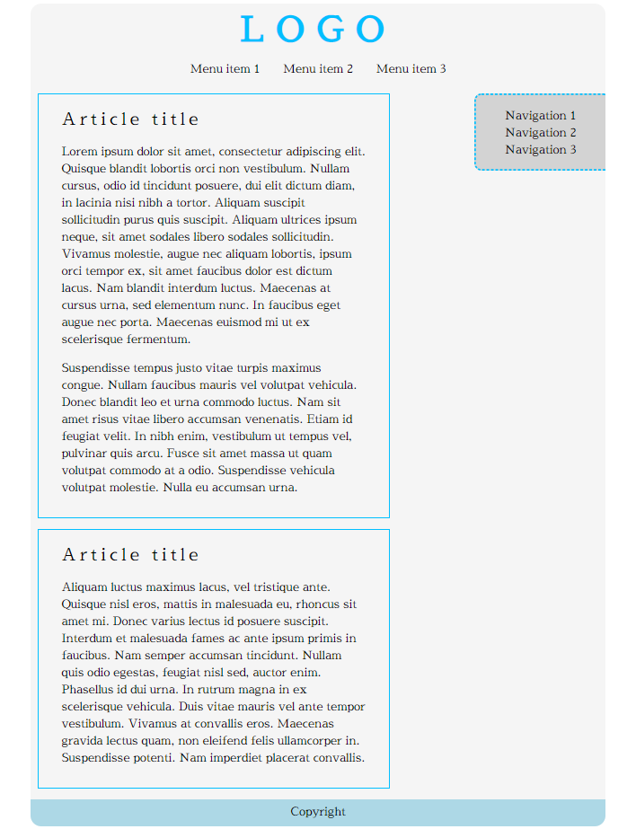
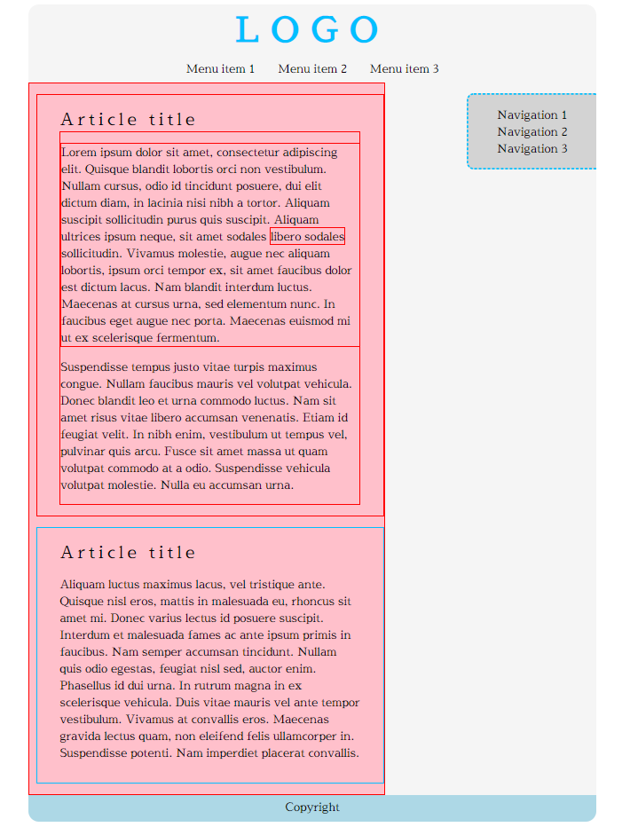

* Bug Tracker
Create a program for managing bug reports. It must perform as a self-contained module with exposed functionality. Whenever a new element is added, deleted or changed with a command, the HTML should be updated automatically. A bug report has the following structure:
{ ID: Number,
author: String,
description: String,
reproducible: Boolean,
severity: Number,
status: String }
The ID of each report has to be a unique number, starting from zero and increasing sequentially. The module needs to implement the following functions:
- report(author, description, reproducible, severity) - create a new bug report and store it. The ID is assigned automatically to the next available number and the status defaults to 'Open'
- setStatus(id, newStatus) - change the status of a bug registered in the system to newStatus by given ID
- remove(id) - delete a bug report by given ID
- sort(method) - change the order in which bug reports are displayed on the webpage. The method argument is a string and can be either 'author', 'severity' or 'ID'. Always sort in ascending order (default behavior for alphabetical sort). The default sorting method is by 'ID'.
- output(selector) - set the HTML element inside which the result is to be displayed to selector
Use the following structure for each HTML report:
index.html
<div id="report_${ID}" class="report">
<div class="body">
<p>${description}</p>
</div>
<div class="title">
<span class="author">Submitted by: ${author}</span>
<span class="status">${status} | ${severity}</span>
</div>
</div>

Input
Input will be passed to each applicable function as parameters in the correct format.

Output
Your solution must expose a module with all required functions bundled in it (return it as a result of your main function). The HTML should be modified as specified.

